PHOTO SPECIFICATIONS
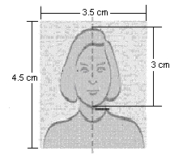
Note: We regret we cannot accept photographs that do not meet these requirements
Please provide one recent photograph (not more than 3 months old) of yourself, which should not have been used previously in the passport. The photograph should be in colour and:
- Taken against a light background (white or off-white) so that features are distinguishable and contrast against the background.
- Clear share quality and with the face in focus.
- Printed on normal photographic paper (camera print).
- Full face, non-smiling [without sunglasses, a hat/cap or other head covering, unless the applicant wears such items because of their religious belief or ethnic background]
- Please stick the Photograph on the Visa Application Form.
Note: Please follow these instructions carefully. If photographs presented do not meet these requirements your application will be considered incomplete. A photo booth meeting these requirements is available at the centre

